CHAPTER 12
Intelligent Automation of Fraud Detection
WE COVER AUDIT RELATED ERRORS AND FRAUD throughout this
book; however, this chapter is dedicated to intelligent financial fraud detection and investigation (IFFDI) using artificial intelligence (AI). The internal controls environment serves as the firewall to protect against fraud. Prevention is different than detection and detection is different than investigation. Detection implies active search to discover, find, uncover, or expose fraud. Investigation begins once a reasonable degree of suspicion develops about the likelihood that a fraud is taking place. In this chapter we will cover both detection and investigation.
When deploying your fraud detection capabilities, you will address questions such as

How to allocate capabilities between prevention, detection, and investigation? What technologies to deploy for each?
When and for what to use deterministic versus stochastic technologies? What methods, models, or techniques should you use?
How do you design and architect your IFFDI system? How to protect your firm from AI‐centric fraud?

DETECTING FRAUD
Fraud happens when material misrepresentations of facts are made intentionally and they lead to loss for one or more victims. The Association of Certified Fraud Examiners (ACFE) classifies fraud against a firm into two types: internal and external (ACFE, n.d.). Internal fraud, also known as occupational fraud, is defined by ACFE as “the use of one's occupation for personal enrichment through the deliberate misuse or misappropriation of the employing organization's resources or assets.” Internal fraud is committed by the managers, employees, owners, or board members of a

firm. External fraud, in contrast, is conducted by parties external to the firm, for example, customers, suppliers, partners.
ACFE classifies internal fraud into three areas: corruption, asset misappropriation, and financial statement fraud. ACFE has developed a powerful and comprehensive representation of internal fraud. Known as the Fraud Tree (Figure 12.1), it covers the various subcategories and subclasses of internal fraud.
Fraud can happen at any point in an organization. For example, it can happen at the employee level, at the board level, or across the value chain via collaboration between partners and even competitors. Detecting fraud is one of the most complex undertakings. Protecting a firm from any possible fraud can be expensive and therefore costs of IFFDI need to be considered.
Let's not forget that in many cases savvy managers operate on the borderline of law and while technically statements and disclosures may not qualify as misrepresentations from a legal perspective, the underlying motivation for business decisions could be self‐serving. For instance, the management team of a nonprofit deploys a CEO friendly board and with the board approval starts making investments in a manner that the CEO intends to personally benefit from in the future. Such situations make fraud detection extremely hard.

ELEMENTS OF FRAUD
In the 1950s, Donald Cressey presented the fraud triangle theory that identified the three fraud elements as pressure, opportunity, and rationalization (Cressey, 1953). A fourth element of capability was later added and the model transformed from a triangle to a diamond (Wolfe and Hermanson, 2004; Mansor, 2015). As we think about intelligent automation, our design elements must first begin by analyzing the elements of fraud and building capabilities around them.

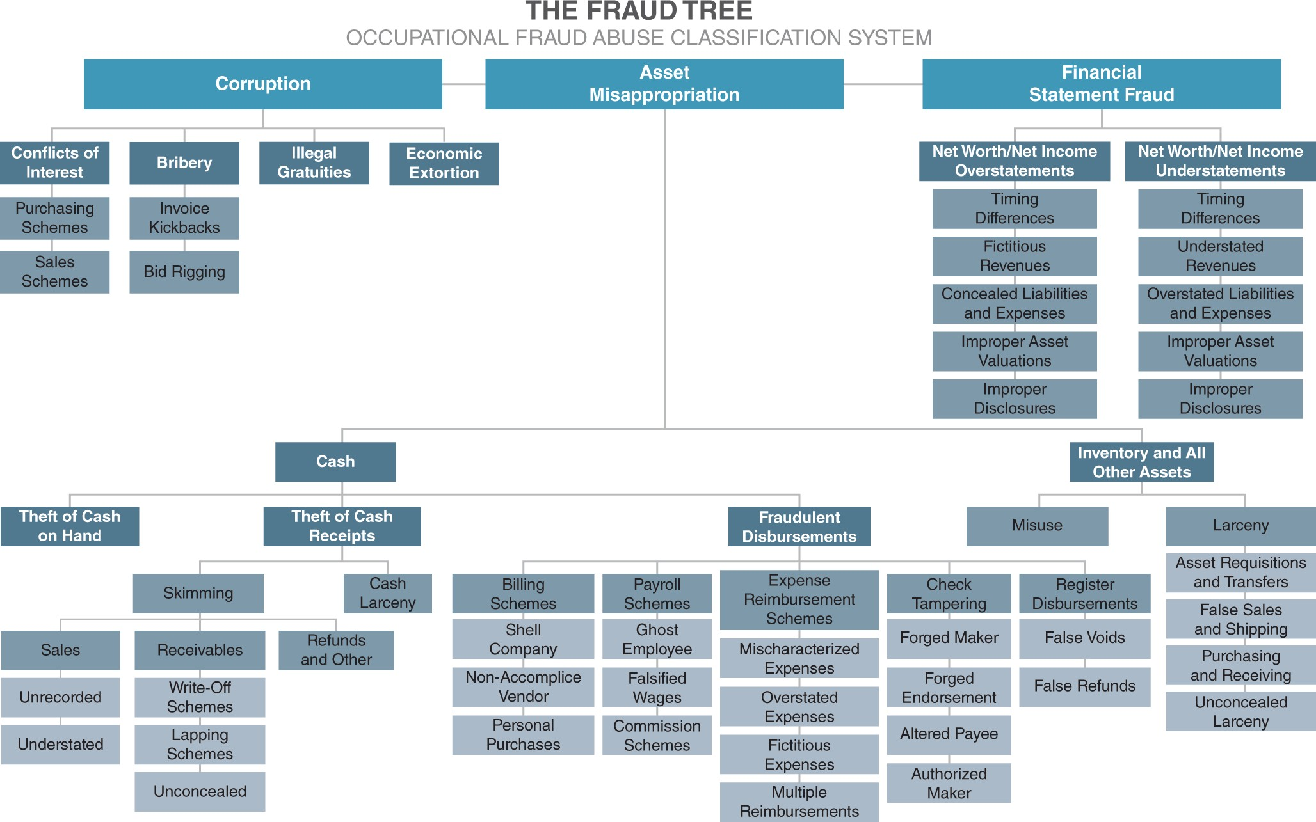
FIGURE 12.1 The Fraud Tree

Pressure or Motivation
Preemptive detection of motivation can go a long way to detect and prevent fraud. Motivation can be anything from personal to business situations. At an individual level it could be when a person is facing financial difficulties and hence decides to engage in a fraud. On a management team level, it could be pressure to report certain earnings numbers for which guidance has been provided. Motivation determination technologies are deployed to evaluate the situations that can motivate a person or management team to commit a fraud. They typically involve understanding the situational dynamics to predict the likelihood of fraud.

Opportunity
The opportunity for fraud is based upon the internal controls weaknesses. An environment that lacks controls or that has a culture that promotes recklessness can be a fertile ground for fraud. The opportunities are identified and exploited by individuals and management teams. Fraud opportunity assessment technology is deployed to assess the control

weaknesses as well as cultural and behavioral modeling to assess the seriousness and desire of the management team and boards to deploy internal controls.

Rationalization
Rationalization is the justification that a person or team gives to the conduct of fraud. This is a self‐deceiving factor where teams and individuals say to themselves that it is okay to engage in a fraudulent behavior for such‐and‐ such reasons. The justification could be that it is a one‐time thing or that they are only borrowing money or that they were denied proper compensation and therefore it is their right to steal. Rationalization detection technology is composed of systems deployed to perform behavioral analysis of individuals and teams.

Capability
Capability is when a person or team believes that they have the capability to get away with doing the fraud, to not get caught, and to pull it off.
Capability detection technology is also used to assess the materiality of the impact a person, machine, or team can have.
AI has been used to combat fraud by building capabilities in accordance with the fraud triangle in practice. For instance, Lin et al. (2015) employed Logistic Regression, Decision Trees, Classification and Regression Trees (CART), and Artificial Neural Networks (ANNs) to study the three aspects of the fraud triangle.

DOMAIN‐SPECIFIC FRAUD DETECTION
The FBI classifies financial frauds into various areas such as securities fraud, credit card fraud, financial statement fraud, insurance fraud, and corporate other fraud. One way to approach your design is to consider each specific domain area in which you have material exposure. This means that specialized solutions need to be developed in those specific domains.
Significant research exists in the use of intelligent automation for domain‐ specific fraud detection (Ngai et al., 2011; West and Bhattacharya, 2016).

STOPSCAM
The American Institute of Artificial Intelligence has developed a model known as STOPSCAM. This model expands upon the domain‐specific model and fraud elements to develop broad classification of fraud by capability areas or detectors that focus on building and deploying intelligent capabilities. STOPSCAM is an acronym for Strategy, Transactions, Operations, Processes, Statements, Culture, Attitudes, and Model.

Strategy
The strategy tool analyzes a company's strategy to obtain key insights to capture signals of significant changes or persistence in a company's strategy. A sudden or abrupt change in strategy, a reluctance to change strategy when it is evident that the strategy is not working, rise of a new competitor, a change in technology, bankruptcy risk, and other strategy concepts are captured and analyzed. Strategy changes also include mergers and acquisitions and major financing events. Automated strategy analysis is performed from analyzing analyst reports, company press releases, and other news and opinions about a firm.

Transactions
Transaction‐level analysis is achieved by deploying systems that scan transaction‐level details. For example, journal entries, G/L, supporting documents inspection, and other similar applications of technology in automated audit forms the baseline for transaction‐level continuous audit with the explicit focus on fraud‐centric anomaly detection. The primary goal in transaction analysis is anomaly detection.

Operations
Operational‐level fraud assessment is done by assessing the operational footprint of a firm and including the value chain of a firm in both directions. This means including the suppliers and partners (e.g., channel partners) and customers to analyze the potential of fraud. In many cases the interaction or structures among partners, subsidiaries, customers, and suppliers shows the presence of fraud.

Processes
Process‐centric evaluation of fraud focuses on understanding anomalous process patterns. These patterns could be based upon transaction patterns, or people accessing systems abnormally, or awkward timings of accessing systems. Process mining technologies, along with machine learning, are used to evaluate this.

Statements
Statement analysis is performed by external parties where publicly available financial statements are analyzed to determine the presence of fraud. This can be based upon analyzing the text or other unstructured data from annual reports, or financial ratio analyses, or by analyzing other company communications, such as earnings call.

Culture
Organizational‐level automated analysis focuses on understanding the culture, management, reporting relationships, social networks, board, and other such factors. Many such factors provide information about potential fraud. For instance, a forceful or overly aggressive CEO with a submissive board can create an environment ripe for fraud.

Attitude
The attitude is the behavioral analysis of the management team and board members. This is a critical part of analysis. Using pictures, videos, text, and other combinations and available data, intelligent automation is used to create a profile of individuals and of social networks. Social networks can exist inside or outside the firm. They can exist between management team members or board members and certain executives. They are formed by shared interests and in terms of structural dynamics, the influence patterns could be completely different than that shown on corporate organizational charts. Understanding those patterns can shed light on how fraud can take shape and who could be involved in that.

Model
A firm's business model is at the heart of its strategies and processes. Changes in the business model can signify several things – including opening up of opportunities for fraud. Technologies used to analyze business models include business process mapping using machine learning (Evermann et al., 2017). The rise of AI in business will also enable businesses to launch new business models (Ehret and Wirtz, 2017).

TECHNOLOGIES AND MODELS
Ngai et al. (2011) performed literature research and showed that a wide variety of approaches are being used in fraud detection. They developed a model where they first outlined the broad categories of frauds such as insurance fraud, securities and commodities fraud, bank fraud, and other financial fraud. Then they further categorized based upon fraudulent activities such as money laundering. And from a solution side they divided the data mining solutions into classification, clustering, outlier detection, prediction, regression, and visualization.
More recently, another group of researchers also performed an extensive survey of fraud detection (West and Bhattacharya, 2016). They, too, first categorized by fraud classes (e.g., insurance, financial statements, etc.). However, they investigated several methods, including neural network, logistic, support‐vector machine, decision trees, genetic algorithms, Bayesian belief network, process mining, artificial immune system, and hybrid methods. Their extensive survey revealed that a diversity of methods are used in intelligent automation.
A third survey of literature used a similar approach to others; however, these researchers divided the machine learning techniques into broad groupings of supervised, unsupervised, and semi‐supervised. They also provide examples of challenges in implementing some of the solutions and techniques of addressing those problems (Abdallah et al., 2016).
The above research is very helpful to learn about various AI approaches being used in different types of business areas. As we have discussed throughout this book, a point solution approach is not enough if you want to build a modern‐era audit or forensic accounting firm. Tools must work

together to form an ecosystem within which various agents can work together to get work accomplished.

OUR APPROACH
We have approached fraud detection not only from the angle of problem area (i.e., fraud category > fraud activity > solution) but also by introducing a class layer for solution deployment in practical business areas (i.e., STOPSCAM agents). The STOPSCAM agents can be deployed in various areas for comprehensive fraud detection. Building a comprehensive fraud detection system requires blending the four key technologies of process mining, robotic process automation, expert systems, and machine learning. Within machine learning various types of models exist and some are better than others for certain types of models.
Strategy, organization, culture, attitude, and business model are automated by algorithms modeling social, behavioral, game theory – centric processes. Transaction and financial statement fraud detection is automated by using anomaly detection, behavioral, and process mining.

Supervised Models in Fraud Detection
Supervised learning techniques are deployed in anomaly detection, social, and behavioral models. Both regression and classification can help in fraud detection. Since supervised techniques are based upon known examples, they are easier to interpret. The main issue with using supervised learning is that we usually (and thankfully) have many more examples of fraud‐free transactions than fraudulent transactions. Therefore, teaching the algorithm becomes harder when, say, for every thousand examples of clean transactions, one example of a fraudulent transaction is provided. There are techniques that can be applied to balance out the examples. For example, one way is to introduce synthetic (made‐up) examples of anomalous behavior. The second limitation is that data requires labeling and unless data is being pulled out of systems where both input and target output values are present for the specific problem being addressed, we may have to rely upon human‐centric labeling of the data. Recall that labeling means providing the target output value for each input vector. That can become quite a laborious project.

Naïve Bayes, support‐vector machines, k‐nearest neighbors, decision trees, logistic regression, deep learning, and artificial neural networks are used to create intelligent artifacts for the various fraud detection applications outlined in the STOPSCAM model.

Unsupervised Techniques
Unsupervised techniques are used in anomaly detection, including in transactions, statements, and processes. They include clustering methods like k‐means, dimensionality reduction methods, subspace based, and classifier based (Goldstein and Uchida, 2016). The goal here is to identify patterns that we don't know exist. As data being analyzed clusters in various segments, it reveals the presence of different patterns. One example of that will be using unsupervised techniques to identify fraud detection in credit card frauds.
Key Points
Fraud detection and fraud prevention are different.
Financial fraud detection automation is performed by intelligent financial fraud detection and investigation.
The general approach for designing fraud detection intelligent automation includes understanding the broad categories of fraud (banking, insurance, healthcare, etc.), identifying the activities within the categories, and then deploying machine learning‐based solutions that include supervised, unsupervised, semi‐supervised, and other methods.
From a solution category perspective, we propose to develop solutions around the STOPSCAM method.

REFERENCES
Abdallah, A., Maarof, M. A., and Zainal, A. (2016) Fraud detection system: A survey. Journal of Network and Computer Applications, 68 (C): 90–

113.
ACFE (n.d.) Association of Certified Fraud Examiners. Available from: https://www.acfe.com/fraud-101.aspx.
Cressey, D. R. (1953) Other People's Money: A Study of the Social Psychology of Embezzlement. Glencoe, IL: Free press.
Ehret, M. and Wirtz, J. (2017) Unlocking value from machines: Business models and the industrial internet of things. Journal of Marketing Management, 33 (1–2): 111–130. Available from: http://dx.doi.org/10.1080/0267257X.2016.1248041.
Evermann, J., Rehse, J. R., and Fettke, P. (2017) Predicting process behaviour using deep learning. Decision Support Systems, 100: 129–140. Available from: http://dx.doi.org/10.1016/j.dss.2017.04.003.
Goldstein, M. & Uchida, S. (2016) A comparative evaluation of unsupervised anomaly detection algorithms for multivariate data. PLoS ONE, 11 (4): 1–31.
Lin, C., Chiu, A., Yan, S, and Yen, D. C. (2015) Detecting the financial statement fraud: The analysis of the differences between data mining techniques and experts' judgments. Knowledge‐Based Systems, 89: 459–
470. Available from: http://dx.doi.org/10.1016/j.knosys.2015.08.011.
Mansor, R. A. N. (2015) Forensic accounting and fraud risk factors: The influence of fraud diamond theory. The American Journal of Innovative Research and Applied Sciences, 7 (28), 186–192. Available from: http://citeseerx.ist.psu.edu/viewdoc/download? doi=10.1.1.695.8486&rep=rep1&type=pdf.
Ngai, E. W. T., Hu, Y., Wong, Y. H., Chen, Y., and Sun, X. (2011) The application of data mining techniques in financial fraud detection: A classification framework and an academic review of literature. Decision Support Systems, 50 (3): 559–569. Available from: http://dx.doi.org/10.1016/j.dss.2010.08.006.
West, J. and Bhattacharya, M. (2016) Intelligent financial fraud detection: A comprehensive review. Computers and Security, 57: 47–66. Available

from: http://dx.doi.org/10.1016/j.cose.2015.09.005.
Wolfe, D. T. and Hermanson, D. R. (2004) The Fraud diamond: Considering the four elements of fraud: Certified public accountant. The CPA Journal, 74 (12): 38–42.

OceanofPDF.com

